**Supply chain Finance and Block chain Technology**In recent years, supply chain finance and blockchain technology have been the focus of attention in China. There are two reasons: one is that as a large manufacturing country, China has a great market capacity; the other is that the innovation in the field of supply chain finance is of great significance to the "made in China 2025" strategy.The characteristics of block chain technology, such as de-centralization and de-trust, can solve several problems :the problems of information asymmetry, complex payment , settlement for supply chain finance and so on .All these ways of resolution show unprecedented vitality in this field.   
**I. the current situation of supply chain finance**Supply chain is the combination of logistics, capital flow and information flow. The ultimate goal of supply chain is to serve supply chain finance and solve the problems of financing cost and capital utilization rate in the whole chain.   
For suppliers, long account period and high financing cost are factors that restrict the development and expansion of enterprises, and even endanger the situation for the tight capital chain. Money is not a problem for core enterprises, actually, how to make more efficient use of these funds to produce benefits is a major issue for enterprise. At the same time, the core enterprises also pay special attention to how to firmly control the upstream suppliers in their own hands, so as to gain a dominant position in the industry competition; Banks are focused on ensuring that information is true and effective and that financing risks are manageable.   
With the development of technology and the liberalization of the financial market, supply chain finance has shown new characteristics: the intensification of competition between banks after the marketization of interest rates, the development of the internet and the internet of things greatly improved the efficiency of information flow and so on. However, there are still many problems, such as accounts receivable is not easy to circulate, accounts receivable pledge financing cost is high, the credit of core enterprises cannot be passed to the second and third level suppliers. Suppliers are unable to integrate in multiple supply chains, and the problem of repeated pledge is difficult to solve.   
The emergence of block chain provides perfect solution for industry: “block chain + supply chain ”has become a new beginning.   
**II. Present situation of Block chain Technology**Block chain technology is not a new technology, but the integration of point-to-point communication, encryption algorithm and other original technologies. The emergence of blockchain technology has a profound impact on us.   
The reason why block chain technology has attracted the attention of the industry is that block chain technology provides a trusted network without third-party centers. This network has the characteristics of security, independence and reliability: all transaction information is recorded by the temporary selection node of the blockchain network; there is no third-party center, it is not controlled by individuals and organizations; the data of all nodes are synchronized in real time. The failure of a single node does not affect the entire system; all transactions are signed and cannot be tampered by others.   
But at the same time, there are still many problems in blockchain technology, such as resource consumption, inefficient accounting and so on. Among them, the inefficiency of bookkeeping is reflected in that the difficulty of random number calculation is not easy to control.   
To solve this problem, a balanced accounting node needs to be found. Therefore, it is necessary to attain a balanced point, the accounting node is undertaken by a large agency, the mechanism of the alliance chain is derived from the block chain, and the bookkeeper of the next block is determined by voting, rotation, and so on. Thus, the problems of resource consumption and bifurcation in bitcoin network are determined, and the block chain technology is commercialized.

1. 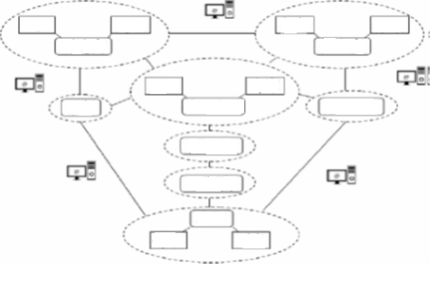

Factory

Factory

warehouse

Bank

Insurance

Manufacturer

supplyer

truck

warehouse

Core company

warehouse

distributor

Retailer

warehouse

customer

Accountant

**III. Problems existing in traditional supply chain Finance**  
The main results are as follows:

(1) the credit information record of suppliers (financing enterprises) is incomplete, and banks can not effectively define their risk level.   
(2) inventory financing and advance financing are limited to traditional mortgage loans, and it is difficult for suppliers and dealers to obtain financing.   
(3) the examination and approval process of manual credit is cumbersome, and it is difficult for small and medium-sized enterprises to obtain credit.   
(4) there is a problem of updating lag in the change of credit line, used amount and remaining amount.   
(5) after the completion of financing, there are some problems, such as timely performance, liquidation lag and so on.

Function

Smart storage

Safely delivery

Anti-Fake

Point

Chain

Net

material flow

Information flow

cash flow

nature

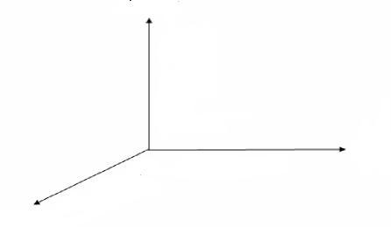  
**IV Solution using Block chain Technology.**  
The above problems can be solved by using blockchain technology.   
The main results are as follows:

Object

(1) writing each transaction record of the financing enterprise into the block chain as the basis of bank credit is helpful to solve the problem that the core enterprise is unwilling to provide credit endorsement.   
(2) based on blockchain technology, supply chain financial business participating institutions can establish an alliance platform for all parties to share information.   
(3) according to the historical record on the block chain, the remaining available amount can be adjusted intelligently.   
(4) to realize timely repayment and liquidation through intelligent contract.   
(5) the supply chain finance platform based on block chain can provide services to all participants and processes of supply chain finance.

**V. Thoughts on the chain of supply chain assets**How to chain the assets in the three modes of accounts receivable financing, prepayment financing and movable property financing in supply chain finance is a problem worthy of attention.   
The most important feature of bitcoin transactions on the chain is that the transfer of value is completed with the completion of the transaction, but in supply chain finance, accounts receivable, prepaid accounts, movable property all exist under the chain, and there is no corresponding assets on the blockchain. Trusted transactions and transfers cannot be carried out directly on the chain, so the physical-digital world association must be carried out by means of digital twinning and so on.   
Accounts receivable and prepaid accounts are relatively easy, both of which are naturally digitized assets. Both parties can register and confirm their respective accounts receivable and prepaid accounts on the chain on their own. In order to form an effective chain contract, the subsequent such assets can flow freely on the chain. When financing is needed, the investors can carry out the following steps after the trade authenticity audit, which is relatively complete with the conditions for the digital transaction on the chain.   
On the other hand, movable property financing has changed. Unlike accounts that can be digitized and homogenized, movable property has a variety of specifications, quality, and status. The authenticity and value of movable properties are difficult to be evaluated and confirmed accurately. This is also the reason why cases such as forgery of warehouse receipts and loan fraud occurred frequently in the past. As for the pledge of movable property completed on the chain, even if it is legally transferred and circulated on the chain, once the pledge right preservation occurs, the real value does not come from the chain, but from the possession of the pledge in the physical world. Only when the authenticity and value of the material are guaranteed can this action be completed.   
There are many solutions that try to solve the binding of physical objects and assets in the chain in the real world, but there is no very effective way to do so. It should be said that this problem appeared before the emergence of the blockchain (which is precisely the reason for the frequent occurrence of previous cases), and the blockchain itself cannot solve this problem, it also needs to be developed through the development of the Internet of things technology. Only when the technology of information collection, evaluation, monitoring and control of physical objects is mature, can the killer application be produced.   
**VI. Summary**In summary, we can see that, unlike some applications in other fields, block chains are made for the sake of block chains, and even make a lot of pseudo requirements. The application of block chains in supply chain finance is natural and natural. The characteristics of block chain completely solve the pain points and problems of supply chain finance, and even play a positive role in the policy of "reducing leverage" at the national level.   
Further, in addition to playing an important role in domestic supply chain finance, block chain finance is also more conducive to the establishment of a trust mechanism for technological rigidity in a complex environment, because the relationship of trust, the mode of supervision, and the control of funds are more complex than the domestic environment. At the same time, the unhindered circulation of digital currency can provide a smooth cross-border value circulation mechanism, we believe that block chain has broader application value and prospect.